HAMILTONIAN AND EULERIAN Group Activity NAME_________________________________________________
1. Each member in your groups should choose ONE of the following four graphs (A-D) and go through ALL justifications for how their graph could or could not be a 1. Hamiltonian Path, 2. Hamiltonian Circuit, 3. Euler Path, and/or 4. Euler Circuit. Each group member should choose a different graph. Each graph many be classified as more than one of the above. Make sure you COMPLETELY justify why your graph can and/or cannot be classified by the given graph names. Show the path that you would take to complete your justification.
A.  | B.  | C.  | D. 
Now work together to solve the following problems. Be prepared to share your GOOD THINK WORK solutions.
2. Given the graph to the right, you plan a vacation and wish to visit every city, but minimize the mileage driven. The vertices represent the cities and the edges represent the distance between the cities in miles.  - Is this scenario creating an Euler path/circuit or a Hamiltonian path/circuit? Explain/Justify why.  - Which route should you take? Explain/Justify why. |  | 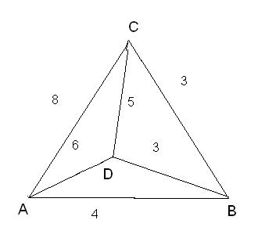EX 2
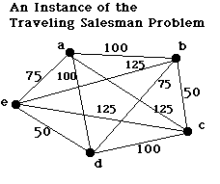 |  | 3. Given the graph at leftYou are a traveling salesman and you have to visit 5 towns (vertices) labeled a through e as shown in the figure. The links (edges) show the cost of each trip.  a. Is this a Hamiltonian or an Euler Circuit? Justify your answer.  b. Find the trip with the minimal cost starting at a. Describe the route using a list of vertices.  c. Give the minimal cost.  d. Describe your strategy for finding the minimal cost.
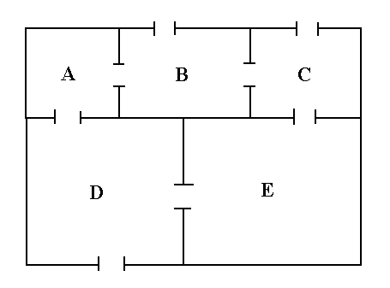 | 4. The real estate agent would like to be able to tour the house, starting and ending outside, by going through each door exactly once.  a. Draw a graph of the house with the rooms and entire “outside” as vertices and doors as edges.  b. Would this situation be considered Eulerian or Hamiltonian? Why?  c. Use the graph to determine whether the real estate agent can go through each door exactly once. Justify your answer.  d. Where could you add a door to make the tour possible? Explain.
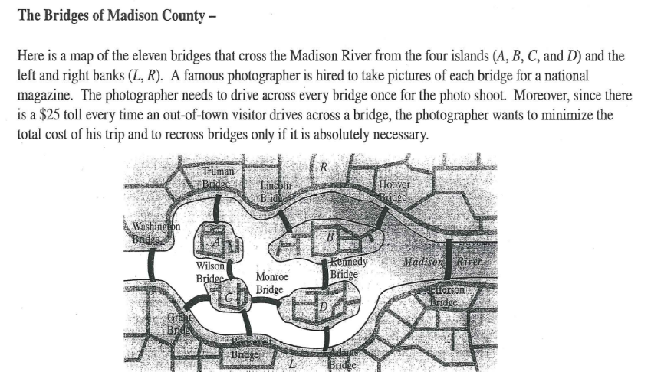 |  |  | 5. a. Is this an Euler or Hamiltonian problem? Why?  b. Draw and label a graph of this problem situation with the land masses as vertices and the bridges as edges.  c. Can the photographer cross each bridge exactly once and end up where she started? Why/Why not?  d. Use the graph to help the photographer find the route that would minimize her costs, if she starting on the right bank. Describe the route using a list of vertices.  e. Find the minimal costs.

