Weighted Averages in Grades
#1 Final Grade Averages
Ashley is a student at Bowie High School enrolled in AQR. She carefully keeps track of all her grades for the first unit and records them in the chart shown.

1. Calculate the average of the following grades (assuming all grades are equally weighted). In the space to the right of the table, explain what process you would use to get your answer.
Assignment | Grade
HW 1-1 | 100
HW 1-2 | 100
HW 1-3 | 105
HW 1-4 | 96
HW 1-5 | 97
HW 1-6 | 100
Quiz #1 | 68
Quiz #2 | 84
Test #1 | 78
HW 2-1 | 100
HW 2-2 | 100
HW 2-3 | 0
HW 2-4 | 96
HW 2-5 | 78
Quiz #3 | 80
Quiz #4 | 92
Test #2 | 84

Average =

When Ashley looks on Gradespeed she is shocked to see that her current average is 83. She is convinced that her teacher has made a mistake and decides to go to school early the following morning to discuss the matter. When Ashley gets to school, she talks with her AQR teacher about her average. Her teacher explains that grades in AQR are weighted. In other words some grades are worth more than others.

How grades are weighted in AQR:
Homework is worth 25% of the total average
Quizzes are worth 25% of the total average
Tests are worth 50% of the total average

2. Step One: Calculate the HW average

3. Step Two: Calculate the Quiz Average

4. Step Three: Calculate the Test Average

5. Ashley's Average using weighted averages

6. Explain the process used to calculate the weighted average.

#2 Grade Point Average

The weighted average of a set of numbers is a special kind of average, in which some elements of the set carry more weight than others. One use for this is calculating a Grade Point Average (GPA).

The credit hours in the table below are the weight. Calculate the (Grade Point)(Credit Hours) for each course and fill in the table. The GPA for this semester is:
$$GPA=\frac{Total of (Grade Point)(Credit Hours)}{(Total Credit Hours)}$$

Course | Letter Grade | Grade Point | Credit Hours | (Grade Point)( Credit Hours)
Computers & Problem Solving | B⁺ | 3.5 | 3.0
Calculus II | B | 3.0 | 4.0
PE | C⁺ | 2.5 | 1.0
Religions of the East | A | 4.0 | 4.0
Russian II | B | 3.0 | 3.0
Total

1. Calculate this student’s GPA.

Weighted Averages in Sports
#3 Slugging Averages

One example of a weighted average in sports is a batter’s slugging average (or percentage) in baseball. The slugging average (SLG) is calculated using the following equation:

$$SLG=\frac{\left(1∙S\right)+\left(2∙D\right)+\left(3∙T\right)+(4∙HR)}{AB}$$

Where S = singles, D = doubles, T = triples, HR = home runs, and AB = total at-bats

Each single has a weight of 1, each double a weight of 2, each triple a weight of 3, and each home run a weight of 4. An at-bat without a hit has a weight of 0.

In his first season with the New York Yankees, Babe Ruth set a record for slugging average that stood for more that 80- years. In 1920, Ruth pounded 172 hits in 458 at-bats, His hits consisted of 73 singles, 36 doubles, 9 triples, and 54 home runs, resulting in a total base count of ($73∙1)+(36∙2)+(9∙3)+(54∙4)=388$. When his total number of bases (388) is divided by his total at-bats (459), the result in .847, his slugging percentage for the season. This record was broken in 2001 by Barry bonds, who had 411 total bases in 476 at-bats for a slugging average of .863. (www.baseball-almanac.com)

1. Find the slugging average for a player with the following statistics:

S = 68
D = 40
T = 4
HR = 16
AB = 320

#4 Quarterback Ratings

The National Football League (NFL) rates quarterbacks for statistical purposes against a fixed performance standard based on the statistical achievements of all qualifies pro passers since 1960. This system allows passing performances to be compared from one season to the next.

The following categories are used to compute the quarterback rating:
- Percent of completions per attempt (%COMP)
- Percent of touchdown passes per attempt (%TD)
- Percent of interceptions per attempt (%INT)
- Average yards gained per attempt (YD)
(from www.nfl.com/help/quarterbackratingformula)

The following is the formula for compiling the quarterback rating (QR):

$$QR=\frac{25+10\left(\%COMP\right)+40\left(\%TD\right)-50\left(\%INT\right)+50(YD)}{12}$$

1. As of 2009, Steve Young has the highest career quarterback rating in NFL history. He completed 2059 passes in 3192 attempts for a total of 25,479 yards, with 174 touchdowns and 85 interceptions. Find Young’s career quarterback rating.

Weighted Sums in Merchandizing
#4 Fan Cost Index

An index is a numerical scale. Characteristics of an index can be used for the following:
- To compare variables with one another or a reference number,
- To give information about general trends, and
- To help make comparisons and judgments.
It is often calculated as a weighted sum of various factors resulting in a single summary number.

The FAN Cost Index (FCI), compiled by Team Marketing Report, tracks the cost for a family of four to attend a professional sporting event. The FCI includes the prices of 2 average-price adult tickets, 2 average-price child tickets, 4 small soft drinks, 2 small other drinks, 4 regular-size hot dogs, parking for 1 car, 2 game programs, and 2 least expensive, adult-size adjustable caps. The Average Ticket Price in the following tables represents the average cost of a ticket for each member of the family.

The FCI for each Texas team in professional baseball, basketball, and football for 2006 is shown in the following table. The Soft Drink Column includes the price of 1 drink and its size in ounces.

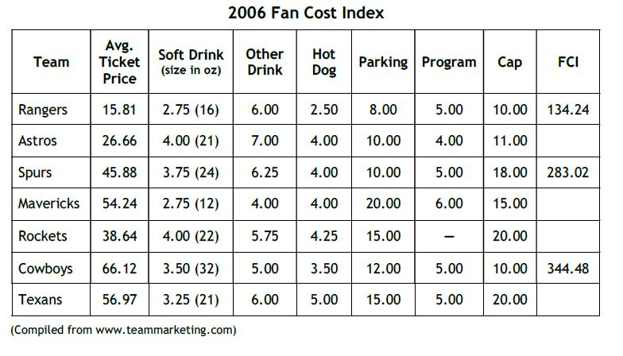
1. Complete the 2006 table by calculating the missing FCI values.

Weighted Sums in Check Digits
#6 Universal Product Codes

Identification numbers are present everywhere in society. Today’s identification numbers are more sophisticated than those introduced years earlier (for example, Social Security numbers). Today’s numbers have a check digit to partially ensure that they have been correctly scanned or entered into a computer.

Universal Product Codes(UPCs), typically in the form of barcodes, identify retail products.
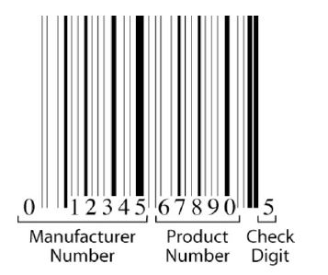
The 12-digit UPC barcode consists of three parts:
- Manufacturer number,
- Product number, and
- Check digit
GS1, formerly the Uniform Code Council, issues a company this six-digit number. Every item sold by a company requires a different five-digit product number. This includes specific products, their different sizes, their array of colors, their variety of flavors, and other distinguishing features. The last number is the check digit, which guards against entry errors and fraud.

The check digit in UPC number (that is, the twelfth digit) is determined in the following manner:
- Multiply the first digit by 3.
- Add the answer to the second digit.
- Multiply the third digit by 3 and add this answer to the previous total
- Add the fourth digit to the previous total
- Continue this alternating process for the digits 5 to 12
The check digit is chosen so that the calculation described previously totals a number whose final digit is 0. In the UPC number a₁a₂a₃a₄a₅a₆a₇a₈a₉a₁₀a₁₁d, the check digit is d, for which the sum

3a₁+a₂+3a₃+a₄+3a₅+a₆+3a₇+a₈+3a₉+a₁₀+3a₁₁+d

ends in 0. In this weighted sum, the weights are {3, 1, 3, 1, 3, 1 ,3, 1, 3, 1, 3, 1}

1. Show that 0-58200-48826-5 is a valid UPC number.

2. Show that 0-52200-48826-5 is an invalid UPC number.

Change one digit in this invalid number so the resulting number is valid.

3. Determine the check digit (d) for the UPC number 38137009213d.

#7 Credit Card numbers

Credit cards have 16-digit numbers, of which the first 15 digits identify the credit card and the sixteenth digit is the check digit. The following figure shows the significance of the digits:
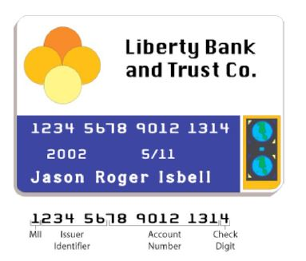
MII stands for major industry identifier; VISA cards begin with 4 and MasterCard cards with 5.

A check digit is used to help validate credit card numbers. The credit card companies use the Codabar method to determine the check digit. This method consists of the following steps:
- Add the digits in the odd-numbered positions and double this total.
- How many odd-position digits are more than 4? Add this number to the previous total
- Add all the even-position digits. Add this total to the previous total
- Choose a check digit that makes the final calculation total a number whose final digit is 0.

1. Show that the check digit (d) for the VISA card 4162 0012 3456 789d is 3.

2. What is the check digit (d) for the MasterCard number 5424 9813 2720 008d?

3. Show that 4128 0012 4389 0110 is an invalid VISA credit card number.

Change one digit in this invalid number so the resulting number is valid.

